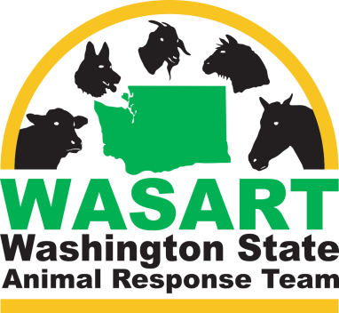
Washington State Animal Response Team

Code of Conduct

WASART volunteers or representatives shall comply with applicable federal, state and local laws and regulations and with WASART policies and regulations including the policies described herein. Incident Commanders (IC) have authority to deactivate any activated WASART volunteer or representative for behavior that violates this Code of Conduct.
All WASART volunteers or representatives shall:
- Project a professional manner and appearance while participating in all WASART related activities.
- Identify operations that are beyond their capabilities based on their qualifications, experience, training, and knowledge.
- Provide and carry professional credentials and display their Emergency Worker Identification badge at all times during activation.
- Observe safety rules and regulations and proper usage and operation of all equipment.
- Accept assignments and/or orders as directed by the Incident Command System (ICS), Incident Commander or other supervising authority, or if required, make discretionary decisions based on appropriate intent and good judgment.
- Not participate otherwise in operations that serve to promote personal gain or ideologies.
- Refrain from entering private properties to perform duties without the express, written permission of the owner, supervising authority, or without a law enforcement escort.
- Remain in contact with the appropriate ICS authority, and confine activities to the assignment deployment and directives of the Incident Action Plan (ICP) if an ICP is prepared.
- Document or participate in documenting each deployment in a timely manner and submit documentation to the appropriate commander or leader.
- Not transport animals to facilities other than those that have been approved by the supervising authority.
- Refrain from taking photographs at a deployment unless authorized to do so by the appropriate supervising authority.
- Not accept any personal donations and shall direct all such donations to the appropriate person.
In addition, the following will not be tolerated while on-site at a deployment, disaster, meeting, conference, or any other activity in which WASART is involved:
- Consumption of alcohol or marijuana while on duty
- Displays of public drunkenness
- Possession, use or selling of any illegal drugs
- Violation of any laws
- Public outbursts or derogatory remarks about other organizations or individuals
- Illegal use or display of a firearm; or
- Carrying a firearm on a deployment, even with a concealed weapon’s permit, without the previously obtained express permission of the Incident Commander of that deployment
CERTIFICATION: I have read the Code of Conduct and agree to abide by the rules set forth herein. I also understand that this statement will become a permanent part of my volunteer personnel file.

NAME (Print)

SIGNATURE DATE

